Part Number: PT925-42160

Kit Contents

|  |  |  |
| --- | --- | --- |
| Item # | Quantity Reqd. | Description |
| 1 | 1 | LH Board Assembly |
| 2 | 1 | RH Board Assembly |
| 3 | 1 | LH Rear Mounting Bracket |
| 4 | 1 | RH Rear Mounting Bracket |
| 5 | 2 | Front Mounting Bracket |
| 6 | 2 | Front Pinch Weld Bracket |
| 7 | 1 | Jack Block |
| 8 | 1 | Jack Decal |
| 9 | 1 | Pinch weld Drill Templates |
| 10 | 1 | Hardware Bag |
| 11 | 1 | Owner’s Manual Decal |
|  |  |  |

Hardware Bag Contents

|  |  |  |
| --- | --- | --- |
| Item # | Quantity Reqd. | Description |
| 1 | 2 | M12 Frame Locking Bolt |
| 2 | 2 | M12 Serrated Flange Nut |
| 3 | 2 | M8 U-Bolt |
| 4 | 2 | M8 Carriage Bolt |
| 5 | 6 | M8 Serrated Flange Nut |
| 6 | 4 | M5 SEMS bolt w/lead in tip |
| 7 | 4 | M5 Flange Nut |
| 8 | 8 | M8 Serrated Flange Bolt |
| 9 | 4 | #12 x ¾” Tech Screw |
|  |  |  |

Additional Items Required For Installation

|  |  |  |
| --- | --- | --- |
| Item # | Quantity Reqd. | Description |
| 1 |  |  |
| 2 |  |  |
| 3 |  |  |
| 4 |  |  |
|  |  |  |

Conflicts

|  |
| --- |
| Hybrid Models |

General Applicability

|  |
| --- |
| All 2016 & later RAV4 gas models |

Recommended Tools

|  |  |
| --- | --- |
| Personal & Vehicle Protection | Notes |
|  |  |
| Special Tools | Notes |
|  |  |
| Installation Tools | Notes |
| Ratchet | 3/8" |
| Shallow Sockets | 8mm, 10mm (1/4” Drive) |
| Deep Sockets | 13mm, 18mm (3/8” Drive) |
| Extension | 3" long (⅜” Drive) 6” long (¼” Drive) |
| Socket Adapter | 3/8” Drive to 1/4” Drive |
| Combination Wrench | 8mm |
| Torque Wrench – Ft Lbs / Nm | 3/8" Drive (3-60 ft lbs / 4-81 Nm) |
| Center Punch |  |
| Drill Motor | 3/8" Drive |
| Drill Bit | 5.5mm Bit (7/32”) |
| Plastic Scraper Tool |  |
| Plastic pry tool |  |
| Allen Socket | 3mm (1/4” Drive) |
| Deburring Tool |  |
| Special Chemicals | Notes |
| Sealer | 3M Pro Auto Body Sealant |

Recommended Sequence of Application

|  |  |
| --- | --- |
| Item # | Accessory |
| 1 | Mudguard |
| 2 | Running Boards |

\*Mandatory

Vehicle Service Parts **(may be required for reassembly)**

|  |  |  |
| --- | --- | --- |
| Item # | Quantity Reqd. | Description |
|  |  |  |

Legend

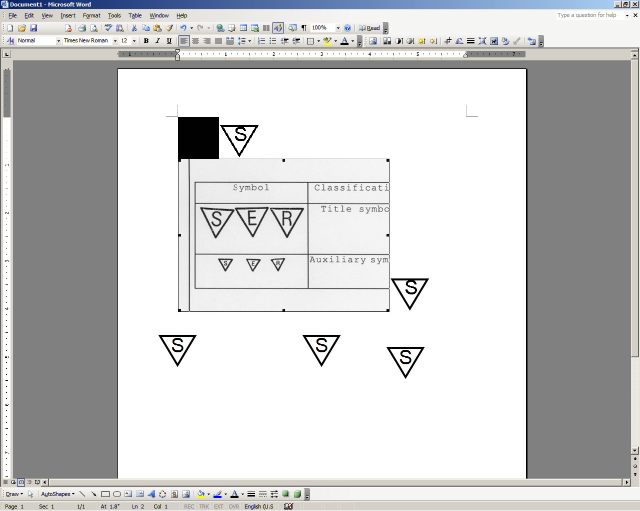

**STOP:** Damage to the vehicle may occur. Do not proceed until process has been complied with.

**OPERATOR SAFETY:** Use caution to avoid risk of injury.

**CAUTION:** A process that must be carefully observed in order to reduce the risk of damage to the accessory/vehicle and to ensure a quality installation.

**TOOLS & EQUIPMENT:** Used in Figures calls out the specific tools and equipment recommended for this process.

**REVISION MARK:** This mark highlights a change in installation with respect to previous issue.  
  
**SAFETY TORQUE:** This mark indicates that torque is related to safety.



Care must be taken when installing this accessory to ensure damage does not occur to the vehicle. The installation of this accessory should follow approved guidelines to ensure a quality installation.

These guidelines can be found in the "Accessory Installation Practices" document.

This document covers such items as:-

* Vehicle Protection (use of covers and blankets, cleaning chemicals, etc.).
* Safety (eye protection, rechecking torque procedure, etc.).
* Vehicle Disassembly/Reassembly (panel removal, part storage, etc.).
* Electrical Component Disassembly/Reassembly (battery disconnection, connector removal, etc.).

Please see your Toyota dealer for a copy of this document.

Prepare for the Installation.

* 1. stop_2Lay out the parts to check for damage. Check the hardware bag contents for correct type and quantity (Fig. 1-1).

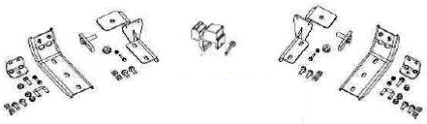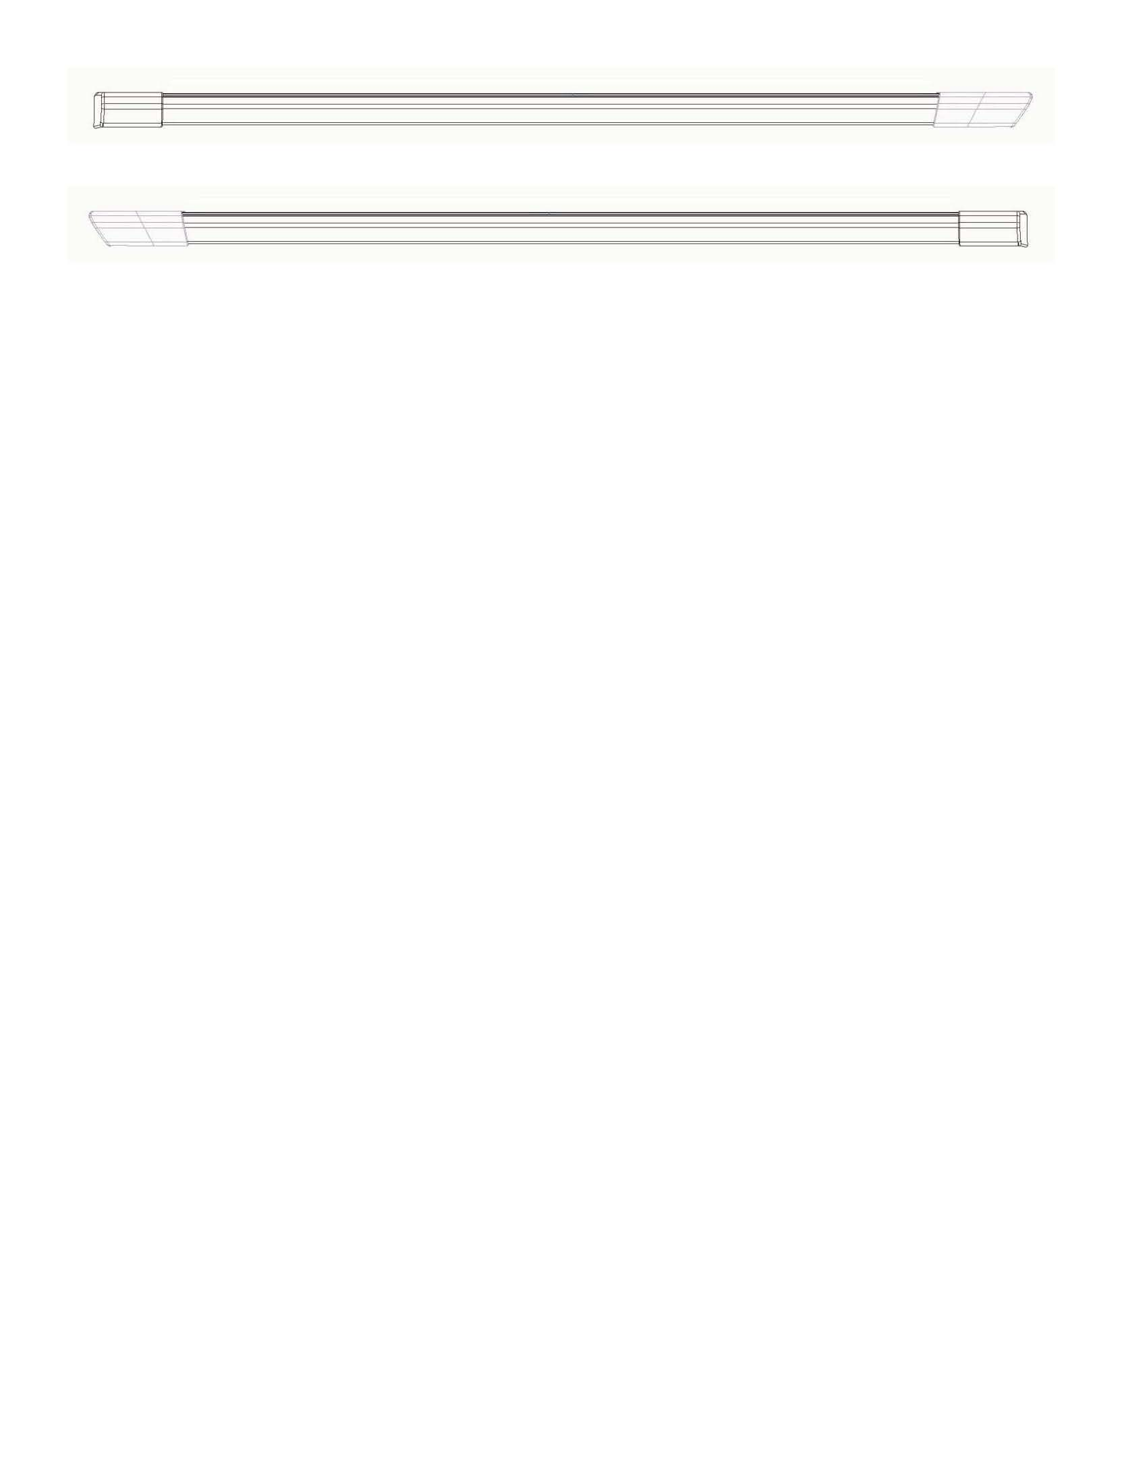

RH

Fig. 1-1

FRONT

FRONT

LH

* 1. Read and understand the entire installation instructions prior to beginning.
  2. The running boards and rear brackets are side specific. The larger end cap of the running board goes to the vehicle front. The rear brackets are marked as LH and RH for side designation.

Remove Parts and Drill.

* 1. Open all four doors before lifting the vehicle to allow access for drilling the pinch welds.
  2. Remove and discard the left and right rear diffusers. Use a 10mm socket to remove the retaining screw (Fig. 2-1).

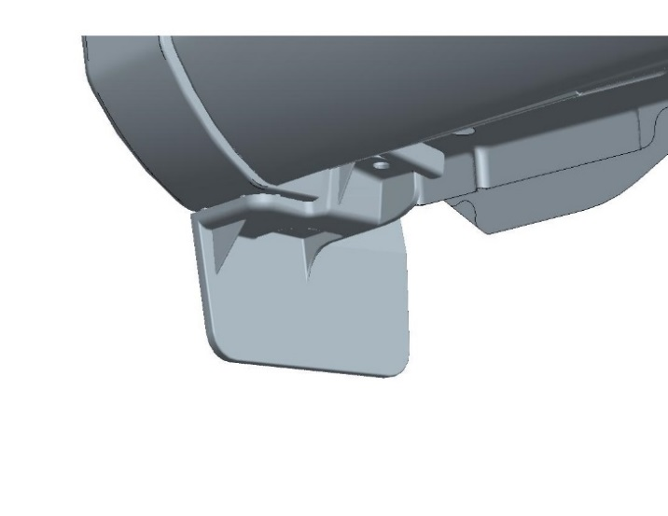

Fig. 2-1

10 mm socket & ratchet, plastic pry tool



Pry tool

10 mm socket

* 1. Insert the blade of a plastic pry tool forward between the diffuser and the underbody. Carefully push in the tab from the top side of the tab downward and slide the diffuser out towards the rear wheel (Fig. 2-1).
  2. Remove and save the right hand plastic undercover and hardware for reattachment. Use a 10mm socket to loosen the three attachment nuts and remove the three push pins (Fig. 2-2).



Fig. 2-2

**Front**

Push pins

10 mm socket, extension & ratchet, plastic pry tool



10 mm socket

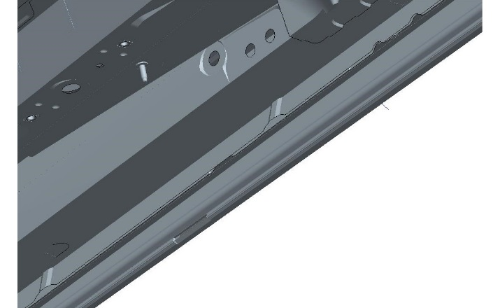

Body sealer

Mylar covers

Fig. 2-3

Plastic scraper



* 1. Remove the two Mylar hole covers on both left and right front underbody to access the front mounting bracket upper attachment holes (Fig. 2-3).

caution_2**Note:** Use a plastic scraper tool or equivalent to remove any body sealer around the two upper front mounting holes that may restrict the mounting bracket from seating into position (Fig. 2-3).

* 1. Locate the front and rear pinch weld drill template positions (Fig. 2-4).

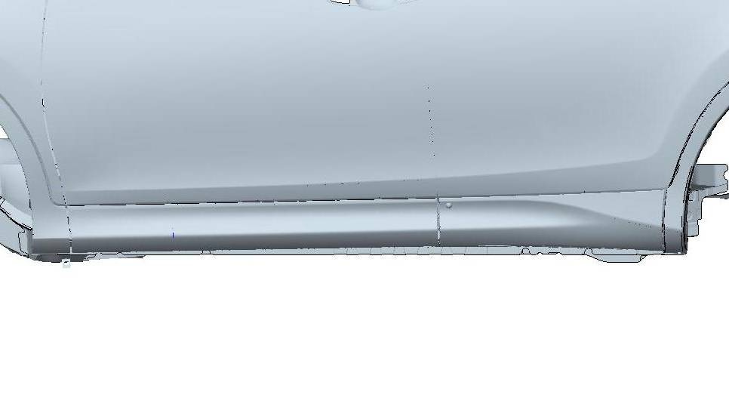

Forward

Fig. 2-4

Pinch Weld Drill Template Positions

Rear

Front

* 1. Remove the pinch weld drill template from the white paper backing and install the template along the jacking point of the pinch weld.
  2. Align the lower edge of the drill template with the bottom of the pinch weld and follow the outer most sheet metal contour (front, Fig. 2-5 and rear, Fig. 2-6).

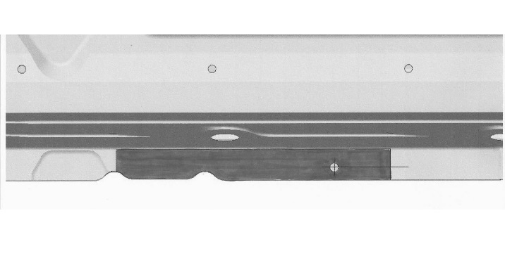

Fig. 2-6

Forward

Front position

3/8” drill with 5.5mm drill bit



8.5mm

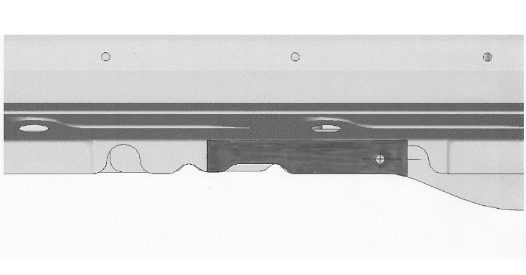

Rear position

Forward

Fig. 2-5

3/8” drill with 5.5mm drill bit



8.5mm

caution_2**Note:** Verify the template notches are in the correct position as shown in Fig. 2-5 and Fig. 2-6.

* 1. Ensure the center of hole is 8.5mm above the bottom of the pinch weld. Mark the center of the hole with a center punch.

caution_2**NOTE:** The position of the Sticky Template is important. Care should be taken to ensure proper positioning before drilling the holes. The brackets can be held in mounting position to verify that all mounting and pinch weld holes align properly before drilling.

* 1. Use a 5.5mm diameter drill bit to drill holes in the front and rear pinch weld location.
  2. Remove the drill templates and deburr the holes of any metal shavings from both sides.

##### Install the Front Left Hand Bracket to the Vehicle.

##### caution_2Note: If needed, remove any OEM pinch weld sealant that may interfere with the proper installation of mounting hardware and/or components.

* 1. Apply body sealant to the drilled 5.5mm hole.
  2. Align the pinch weld bracket to the outside of the pinch weld. Install a M5 SEMS bolt from the inside drilled pinch weld hole outward through the bracket forward hole. Finger tighten the nut (Fig. 3-1).

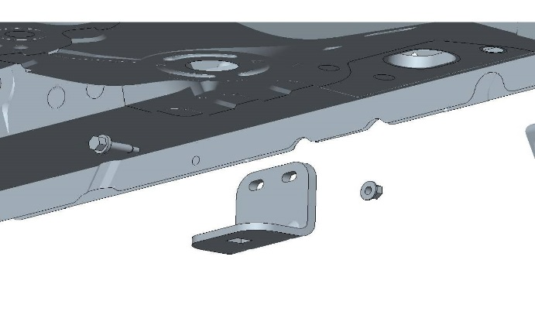

Fig. 3-1

Forward

Rear pinch weld

* 1. Install a plastic retaining clip to the midpoint of the threads on a M8 U-bolt (Fig. 3-2).

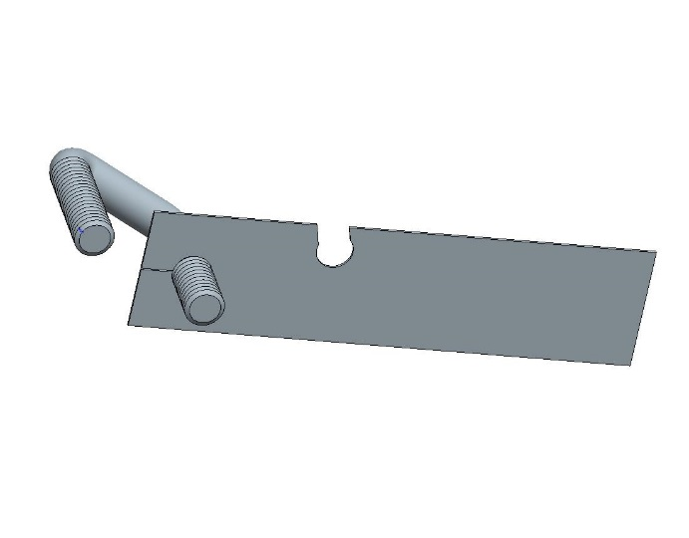

Fig. 3-2

caution_2**Note:** Be sure to align the secondary retaining notch facing inward of the U-bolt as shown in Fig. 3-2.

* 1. caution_2Hold the plastic retaining clip and guide the U-bolt through the upper front mounting bracket holes (Fig. 3-3).

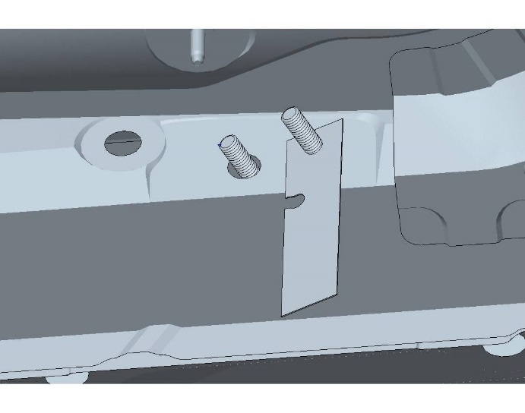

Fig. 3-3

* 1. caution_2Swing the plastic retaining clip over to the other side of the U-bolt and connect the secondary retaining notch to the U-bolt (Fig. 3-4).

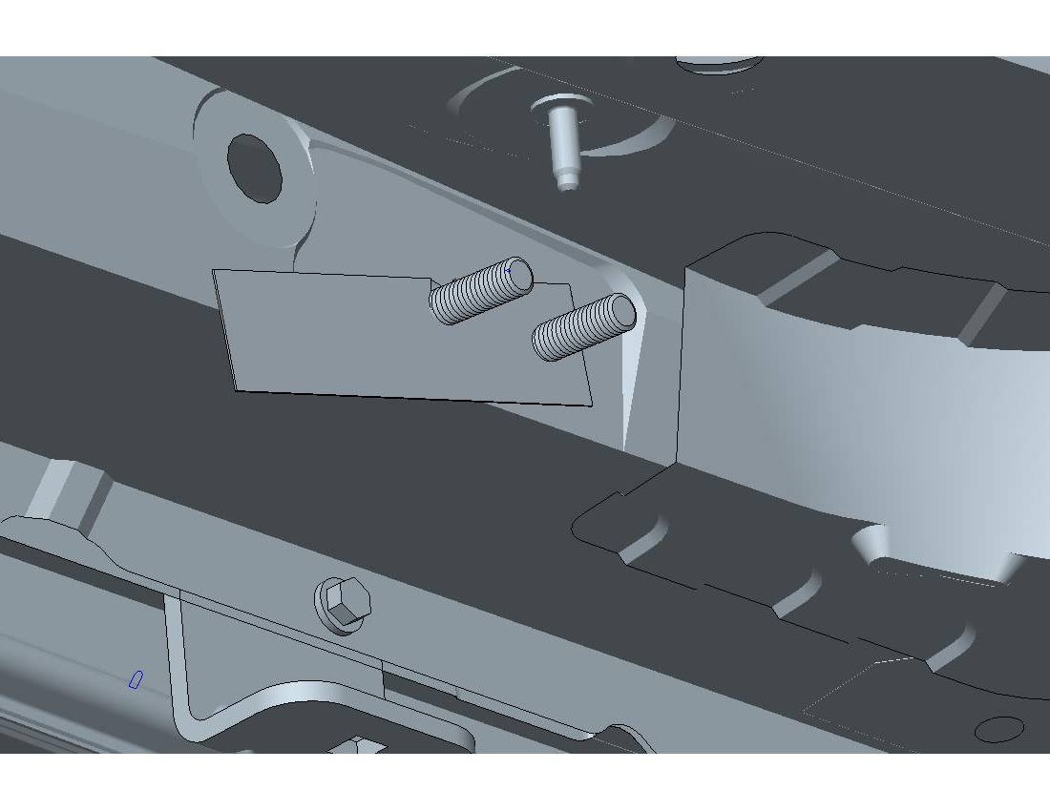

Fig. 3-4

* 1. With the plastic U-bolt retaining clip firmly in place, align the front bracket upper mounting holes with the U-bolt and guide the bracket into place (Fig. 3-5).

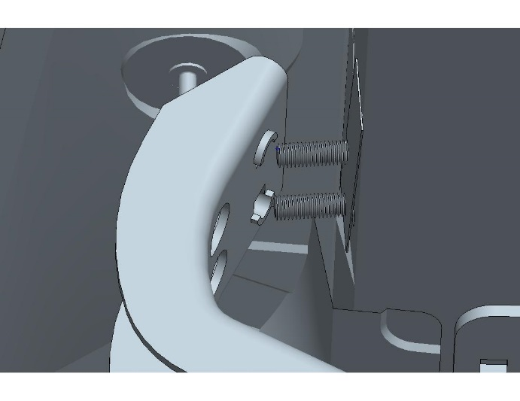

Fig. 3-5

* 1. Loosely install the two M8 flange nuts to the U-bolt until the U-bolt just passes through nut.
  2. Remove the plastic U-bolt retaining clip by releasing the secondary retaining notch, then twist and pull the clip out.

##### caution_2Note: Save the plastic retaining clip for use on the right side installation.

Fig. 3-4

* 1. Swing the front mounting bracket up to the pinch weld bracket and attach a M8 carriage bolt finger tight (Fig. 3-6).

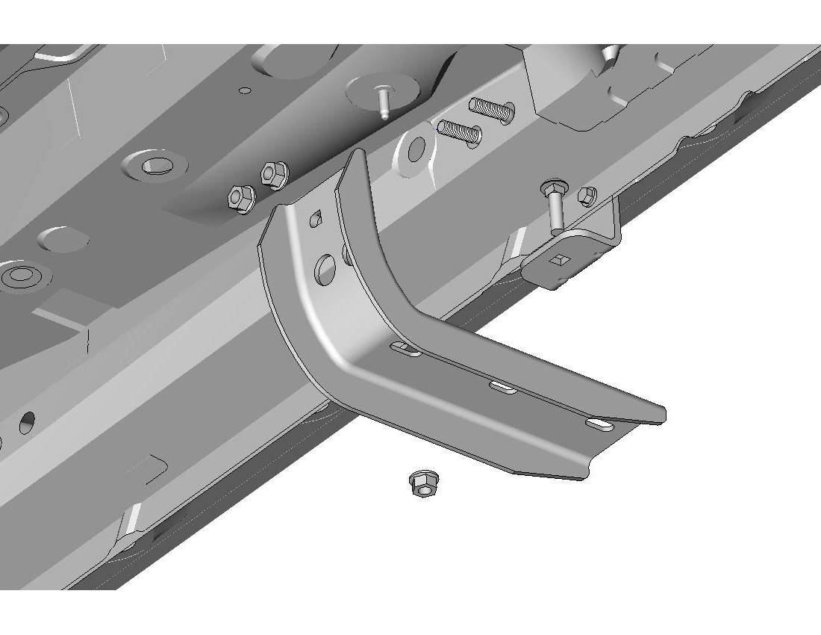

Forward

Fig. 3-6

M8 carriage bolt

M5 bolt

M8 U-bolt

8mm socket, 13mm deep socket & ratchet



* 1. Snug all front mounting bracket hardware (M5 and M8).

caution_2**Note:** Make sure that the bracket is parallel to the ground. It is important to tighten the U-bolt nuts in equal increments from side to side.

* 1. From the inside, torque the front M5 bolt to 5 N-m (48 in-lb).

**Torque: 5 N-m (48 in-lb)**

* 1. Torque the M8 carriage nut to 23 N-m (17 ft-lb).

##### Torque: 23 N-m (17 ft-lb)

* 1. Torque both front bracket U-bolts in 3 steps: 7 N-m (60 in-lb), 14 N-m (10 ft-lb) and a final torque of 23 N-m (17 ft-lb).



Follow this torque sequence

1st Step: Torque: 7 N-m (60 in-lb)

2nd Step: Torque: 14 Nm (10 ft-lb)

3rd Step: **Torque: 23 N-m (17 ft-lb)**

caution_2**Note:** It is important to tighten the U-bolt nuts in equal increments from side to side.

##### Install the Rear Left Hand Bracket to the Vehicle.

##### caution_2Note: If needed, remove any OEM pinch weld sealant that may interfere with the proper installation of the mounting hardware and/or components.

* 1. Apply body sealant to the drilled 5.5mm hole.
  2. Insert a M12 frame locking bolt into the rear tie-down hole on the vehicle with the long section of the frame locking tab towards the rear of the vehicle (Fig. 4-1).

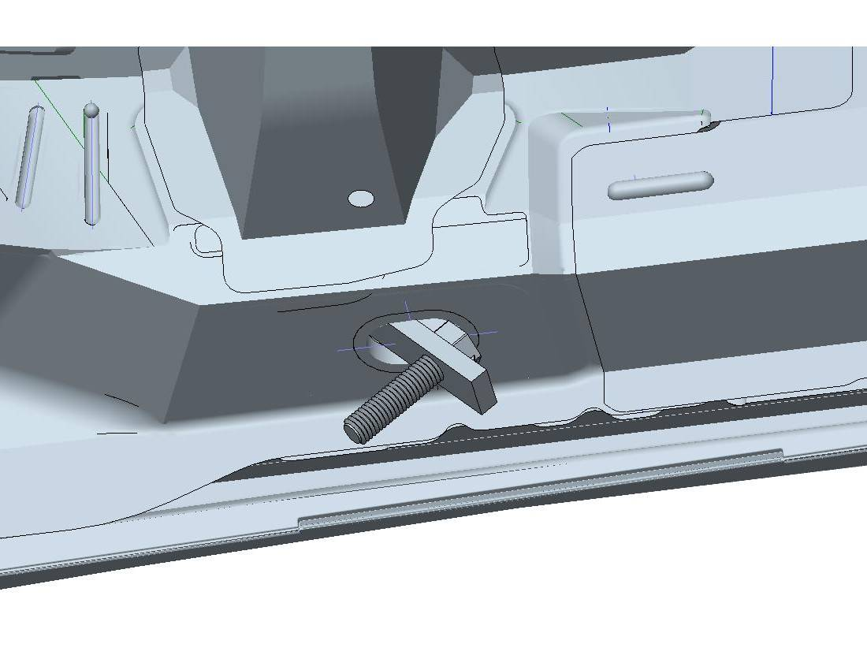

Fig. 4-1

Rear

* 1. Insert the short side up into the hole completely and slide the bolt forward (Fig. 4-2).

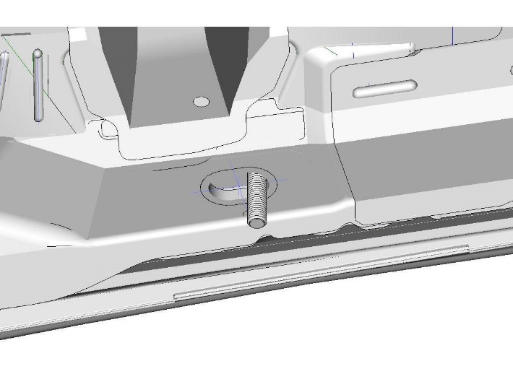

Fig. 4-2

caution_2**Note:** Verify that the frame locking bolt tab is completely inserted into the mounting hole before continuing to the next step.

* 1. Guide the M12 frame locking bolt through the hole in the rear mounting bracket and finger tighten a M12 flange nut (Fig. 4-3).

Fig. 4-3

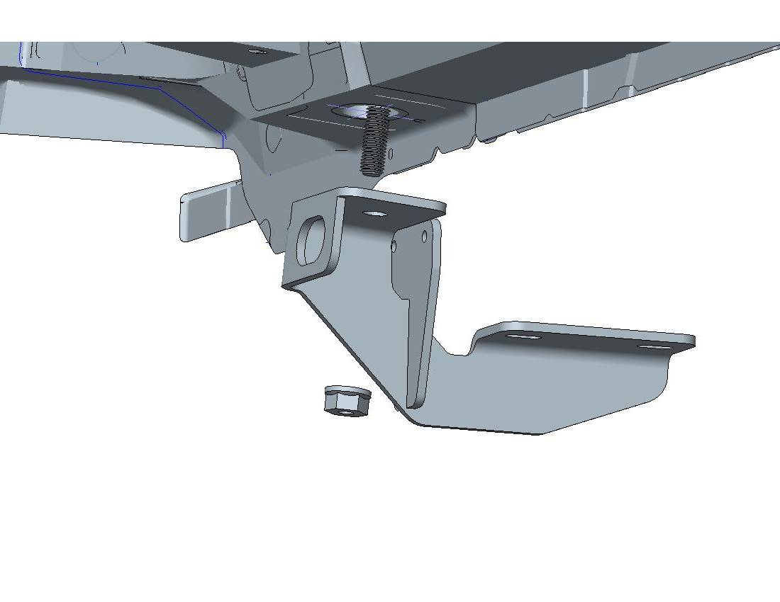

Fig. 4-3

* 1. Swing the rear bracket up to the pinch weld. Install a M5 SEMS bolt from the inside drilled pinch weld hole outward through the bracket. Finger tighten the nut (Fig. 4-4).

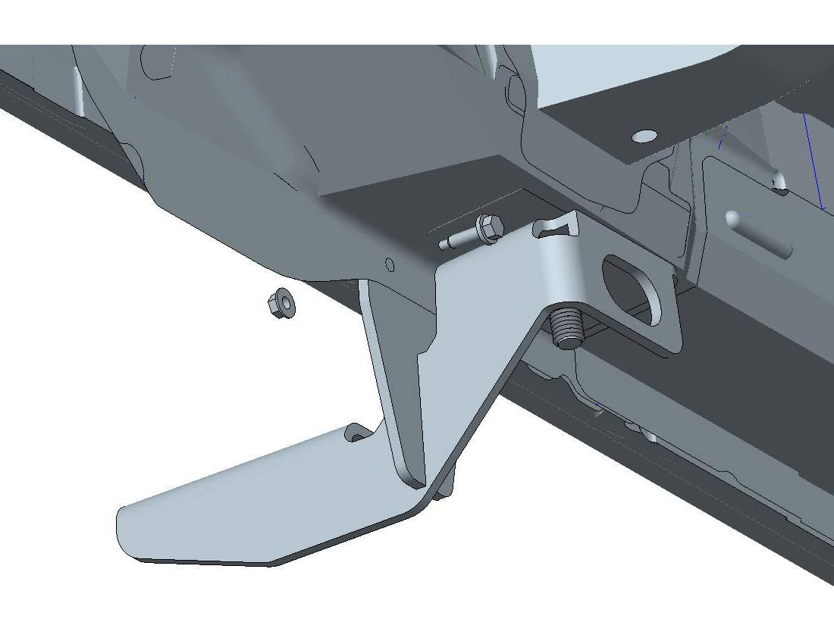

Fig. 4-4

8mm socket & wrench, 18mm socket and ratchet



* 1. From the inside, torque the M5 SEMS bolts to 5.5 N-m (48 in-lb).

**Torque: 5.5 N-m (48 in-lb)**

* 1. Torque the rear bracket M12 nut to 81 N-m (60 ft-lb).

**Torque: 81 N-m (60 ft-lb)**

##### Install the Left Hand Running Board to the Bracket.

caution_2**Note:** The running boards are side specific. The larger end cap goes to the FRONT of the vehicle.

caution_2**NOTE:** If the vehicle does not have mudguards, skip to Step 5(d).

caution_2**NOTE:** If the running boards are installed with mudguards, it is necessary to adjust the front end cap position. Follow Steps 3(a) - 3(c).

* 1. Remove the 2 tech screws from the front end cap (Fig. 5-1).

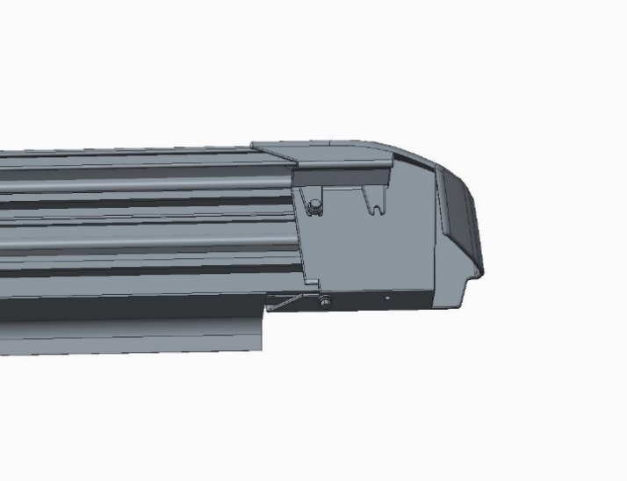

Fig. 5-1

Tech screws

* 1. Push the end cap in until the forward set of the end cap mounting holes align with the holes in the running board (Fig. 5-2).

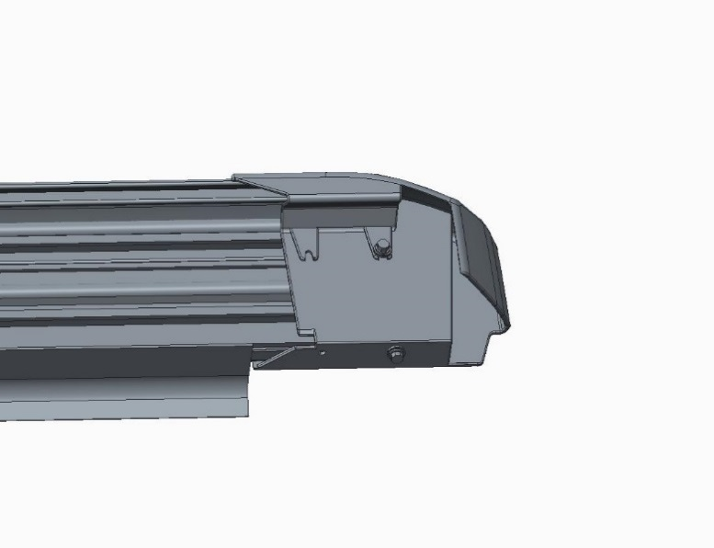

Fig. 5-2

Tech screws

Push end cap

* 1. Replace the tech screws. Use the provided replacement screw (Fig. 5-2).

caution_2**NOTE:** Start here if the vehicle does not have mudguards.

* 1. Close the vehicle doors.
  2. Slide the gap guard to the front end cap (Fig. 5-3).

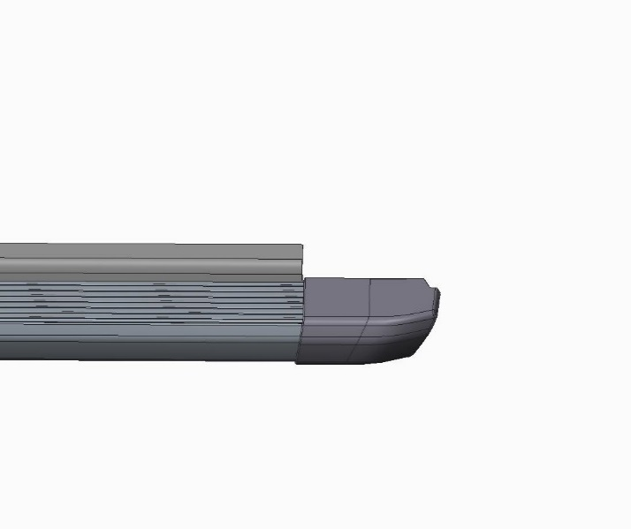

Fig. 5-3

caution_2**NOTE:** The gap between the gap guard and the rear end cap is normal, especially when installed without a mudguard.

* 1. Slide the two running board nut locators to the center of the running board (Fig. 5-4).

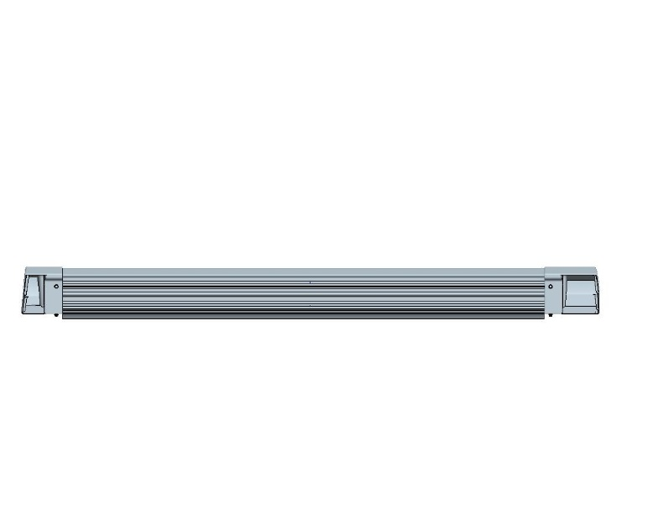

Fig. 5-4

Nut locators

* 1. Set the running board onto the brackets, tilt the board and slide it inward (Fig. 5-5).

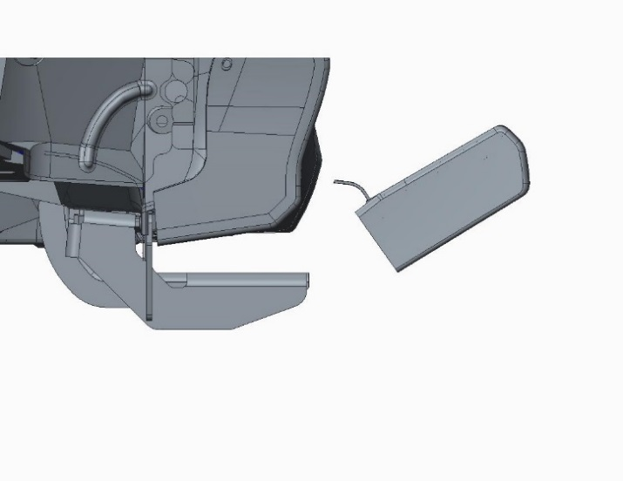

Fig. 5-5

* 1. Align the rear edge of the running board with the edge of the fender flare (Fig. 5-6).

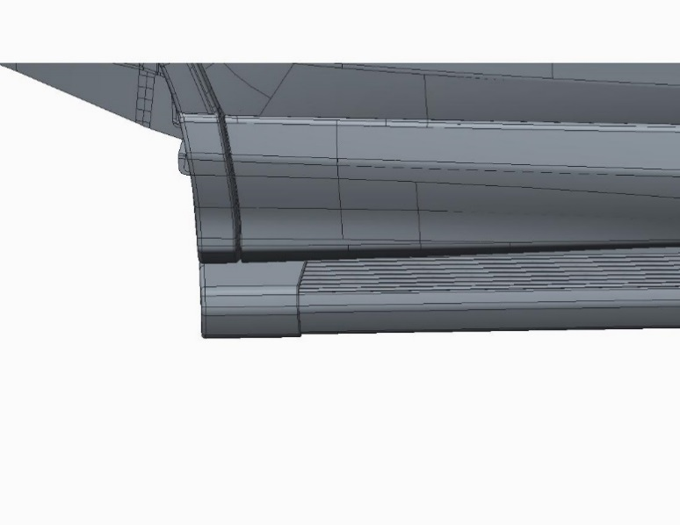

Fig. 5-6

Align edge of board with fender flare

* 1. Slide the running board nut locators to the edge of the mounting brackets and pull the locators out of the track nuts. Use the end of the locator to slide the track nuts into position, lining it up with the holes in the mounting bracket.
  2. Loosely install four M8 flange bolts into the track nuts.
  3. Align the bolts to the outer-most slot position and torque the four flange bolts to 23 N-m (17 ft-lb).

**Torque: 23 N-m (17 ft-lb)**

##### Install the Right Hand Side Brackets and Running Boards.

* 1. Repeat Steps 2 through 5 for the right hand side installation.

##### Re-Torque all Hardware.

* + - * 1. caution_2Starting with the left hand side, perform a re-torque as follows:
  1. From the inside, torque the front M5 bolt.

**Torque: 5 N-m (48 in-lb)**

* 1. Torque the M8 carriage nut.

**Torque: 23 N-m (17 ft-lb)**

* 1. Torque both front bracket U-bolt nuts.

**Torque: 23 N-m (17 ft-lb)**

* 1. From the inside, torque the pinch tab on the rear bracket to pinch weld M5 bolt.

**Torque: 5.5 N-m (48 in-lb)**

* 1. Torque the rear bracket M12 nut.

**Torque: 81 N-m (60 ft-lb)**

* 1. Torque the four running board bracket flange nuts.

**Torque: 23 N-m (17 ft-lb)**

* 1. Repeat Step 7 on the right hand side.

##### Reinstall the Plastic Undercover.

* 1. Use the attaching hardware removed in Step 2(d) to reinstall the plastic undercover (Fig. 8-1).



Fig. 8-1

**Front**

Push pins

10 mm socket & ratchet, plastic pry tool



10 mm socket

* + 1. caution_2Install the three plastic push pins first.
    2. Use a 10mm socket and extension to install the three nuts.

##### Place the Jack Warning Sticker.

* 1. Remove the jack from the rear cargo compartment.

caution_2**Note:** Make sure the jack is free of dirt and grease.

* 1. Place the yellow warning sticker 3mm from the top edge of the jack arm (Fig. 9-1).

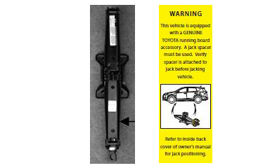

3mm



Fig. 9-1

##### Install the Jack Block.

* 1. Remove the M5 button head screw from the jack block.
  2. toolMatching contours, set the jack block down on the jack and reinstall the button head screw (Fig. 10-1).

3 mm hex head socket torque wrench

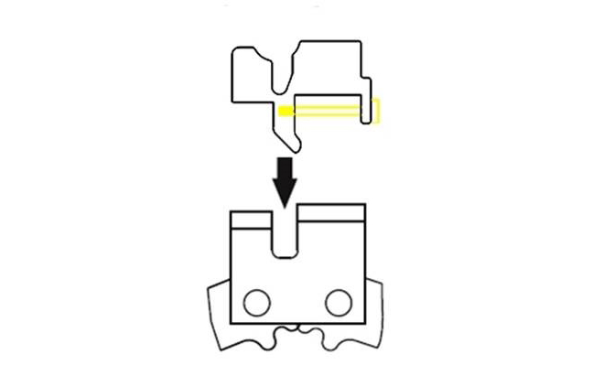

Jack

Fig. 10-1

Jack block

* 1. Torque the jack block screw to 4 N-m (36 in- lb).

**Torque: 4 Nm (36 in-lb)**

* 1. Position the jack face down and place it back into the jack compartment (Fig. 10-2).

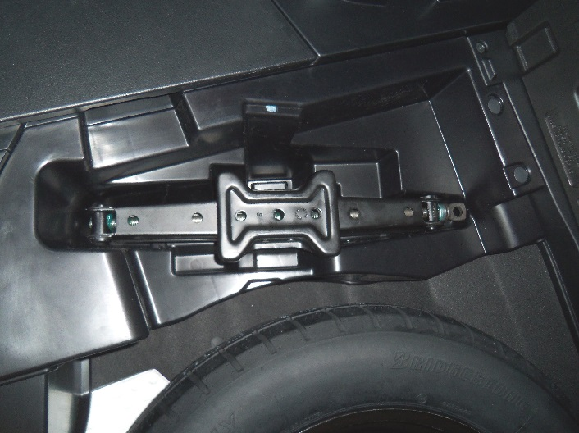

Fig. 10-2

caution_2**NOTE:** Make sure the jack is properly secured.

##### Place the Owner’s Manual Sticker.

* 1. Retrieve the vehicle Owner’s Manual from the glove compartment.
  2. Go to the Red Section: “WHEN TROUBLE ARISES”.
  3. Locate the “If you have a flat tire” page.

caution_2**NOTE:** The page numbers may be different from manual to manual. Always refer to the “If you have a flat tire” page.

* 1. In this section at the top inside edge, place the yellow 12mm x 76mm warning sticker as shown in Fig. 11-1.

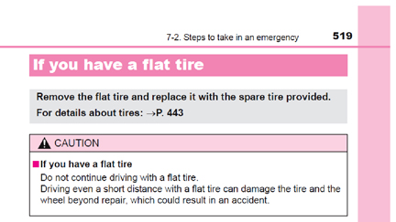

Fig. 11-1

* 1. Go to the inside back cover of the vehicle manual**.**
  2. Place the white 101mm x 76mm sticker on the inside of the cover (Fig. 11-2).

Approximately ½”



* 1. Replace the Owner’s Manual in the glove compartment.

Fig. 11-2

Accessory Function Checks

Inspect bolt torque

Warning decals have been placed in Owner’s Manual

Vehicle Function Checks

Verify that there is no interference with front Mud Guard

Verify all of the torque values

Top left of Red Section: “WHEN TROUBLE ARISES” and inside back cover.

Vehicle Appearance Check

After accessory installation and removal of protective cover(s), perform a visual inspection.

Ensure no damage (including scuffs and scratches) was caused during the installation process.

(For PPO installations, refer to TMS Accessory Quality Shipping Standard.)